from keras.models import Sequential
from keras.layers import Convolution2D
from keras.layers import MaxPooling2D
from keras.layers import Flatten
from keras.layers import Dense
from keras.models import model_from_json
pip install matplotlib
Collecting matplotlibNote: you may need to restart the kernel to use updated packages.
Downloading matplotlib-3.6.2-cp39-cp39-win_amd64.whl (7.2 MB)
---------------------------------------- 7.2/7.2 MB 17.8 MB/s eta 0:00:00
Requirement already satisfied: pyparsing>=2.2.1 in c:\users\likitha s\appdata\local\programs\python\python39\lib\site-packages (from matplotlib) (3.0.9)
Requirement already satisfied: packaging>=20.0 in c:\users\likitha s\appdata\local\programs\python\python39\lib\site-packages (from matplotlib) (21.3)
Requirement already satisfied: pillow>=6.2.0 in c:\users\likitha s\appdata\local\programs\python\python39\lib\site-packages (from matplotlib) (9.3.0)
Collecting kiwisolver>=1.0.1
Downloading kiwisolver-1.4.4-cp39-cp39-win_amd64.whl (55 kB)
---------------------------------------- 55.4/55.4 kB 3.0 MB/s eta 0:00:00
Collecting fonttools>=4.22.0
Downloading fonttools-4.38.0-py3-none-any.whl (965 kB)
------------------------------------- 965.4/965.4 kB 20.8 MB/s eta 0:00:00
Requirement already satisfied: python-dateutil>=2.7 in c:\users\likitha s\appdata\local\programs\python\python39\lib\site-packages (from matplotlib) (2.8.2)
Collecting contourpy>=1.0.1
Downloading contourpy-1.0.6-cp39-cp39-win_amd64.whl (161 kB)
-------------------------------------- 161.3/161.3 kB 9.4 MB/s eta 0:00:00
Requirement already satisfied: numpy>=1.19 in c:\users\likitha s\appdata\local\programs\python\python39\lib\site-packages (from matplotlib) (1.23.4)
Collecting cycler>=0.10
Using cached cycler-0.11.0-py3-none-any.whl (6.4 kB)
Requirement already satisfied: six>=1.5 in c:\users\likitha s\appdata\local\programs\python\python39\lib\site-packages (from python-dateutil>=2.7->matplotlib) (1.16.0)
Installing collected packages: kiwisolver, fonttools, cycler, contourpy, matplotlib
Successfully installed contourpy-1.0.6 cycler-0.11.0 fonttools-4.38.0 kiwisolver-1.4.4 matplotlib-3.6.2
import matplotlib.pyplot as plt
import warnings
warnings.filterwarnings('ignore')
batch_size = 32
from tensorflow.keras.preprocessing.image import ImageDataGenerator
train_datagen = ImageDataGenerator(rescale=1/255)
train_generator = train_datagen.flow_from_directory("C:/Users/LIKITHA S/Downloads/ibmjaya/data/body",target_size = (200,200),batch_size = 32,class_mode = "categorical")
train_generator= train_datagen.flow_from_directory("C:/Users/LIKITHA S/Downloads/ibmjaya/data/level",target_size = (200,200),batch_size = 32,class_mode = "categorical")
Found 1150 images belonging to 1 classes.
Found 1150 images belonging to 1 classes.
import tensorflow as tf
model = tf.keras.models.Sequential([
# Note the input shape is the desired size of the image 200x 200 with 3 bytes color
# The first convolution
tf.keras.layers.Conv2D(16, (3,3), activation='relu', input_shape=(200, 200, 3)),
tf.keras.layers.MaxPooling2D(2, 2),
# The second convolution
tf.keras.layers.Conv2D(32, (3,3), activation='relu'),
tf.keras.layers.MaxPooling2D(2,2),
# The third convolution
tf.keras.layers.Conv2D(64, (3,3), activation='relu'),
tf.keras.layers.MaxPooling2D(2,2),
# The fourth convolution
tf.keras.layers.Conv2D(64, (3,3), activation='relu'),
tf.keras.layers.MaxPooling2D(2,2),
# The fifth convolution
tf.keras.layers.Conv2D(64, (3,3), activation='relu'),
tf.keras.layers.MaxPooling2D(2,2),
# Flatten the results to feed into a dense layer
tf.keras.layers.Flatten(),
# 128 neuron in the fully-connected layer
tf.keras.layers.Dense(128, activation='relu'),
# 5 output neurons for 5 classes with the softmax activation
tf.keras.layers.Dense(3, activation='softmax')
])
model.summary()
Model: "sequential"
_________________________________________________________________
Layer (type) Output Shape Param #
=================================================================
conv2d (Conv2D) (None, 198, 198, 16) 448
max_pooling2d (MaxPooling2D (None, 99, 99, 16) 0
)
conv2d_1 (Conv2D) (None, 97, 97, 32) 4640
max_pooling2d_1 (MaxPooling (None, 48, 48, 32) 0
2D)
conv2d_2 (Conv2D) (None, 46, 46, 64) 18496
max_pooling2d_2 (MaxPooling (None, 23, 23, 64) 0
2D)
conv2d_3 (Conv2D) (None, 21, 21, 64) 36928
max_pooling2d_3 (MaxPooling (None, 10, 10, 64) 0
2D)
conv2d_4 (Conv2D) (None, 8, 8, 64) 36928
max_pooling2d_4 (MaxPooling (None, 4, 4, 64) 0
2D)
flatten (Flatten) (None, 1024) 0
dense (Dense) (None, 128) 131200
dense_1 (Dense) (None, 3) 387
=================================================================
Total params: 229,027
Trainable params: 229,027
Non-trainable params: 0
_________________________________________________________________
from tensorflow.keras.optimizers import RMSpropearly = tf.keras.callbacks.EarlyStopping(monitor='val_loss',patience=5)
model.compile(loss='categorical_crossentropy',
optimizer=RMSprop(lr=0.001),
metrics=['accuracy'])
Cell In [23], line 1
^
from tensorflow.keras.optimizers import RMSprop
early = tf.keras.callbacks.EarlyStopping(monitor='val_loss',patience=5)
model.compile(loss='categorical_crossentropy',
optimizer=RMSprop(lr=0.001),
metrics=['accuracy'])
total_sample=train_generator.n
n_epochs = 20
history = model.fit_generator(
train_generator,
steps_per_epoch=int(total_sample/batch_size),
epochs=n_epochs,
verbose=1)
Epoch 1/20
35/35 [==============================] - 30s 750ms/step - loss: 783391.3750 - accuracy: 0.2370
Epoch 2/20
35/35 [==============================] - 27s 768ms/step - loss: 27040398.0000 - accuracy: 0.3283
Epoch 3/20
35/35 [==============================] - 28s 788ms/step - loss: 202330656.0000 - accuracy: 0.3435
Epoch 4/20
35/35 [==============================] - 25s 701ms/step - loss: 839549952.0000 - accuracy: 0.3506
Epoch 5/20
35/35 [==============================] - 27s 779ms/step - loss: 2527217664.0000 - accuracy: 0.3381
Epoch 6/20
35/35 [==============================] - 28s 787ms/step - loss: 6105253888.0000 - accuracy: 0.3131
Epoch 7/20
35/35 [==============================] - 26s 753ms/step - loss: 13130227712.0000 - accuracy: 0.3587
Epoch 8/20
35/35 [==============================] - 26s 730ms/step - loss: 26335082496.0000 - accuracy: 0.3435
Epoch 9/20
35/35 [==============================] - 24s 696ms/step - loss: 47162097664.0000 - accuracy: 0.3157
Epoch 10/20
35/35 [==============================] - 27s 781ms/step - loss: 81488052224.0000 - accuracy: 0.3462
Epoch 11/20
35/35 [==============================] - 32s 925ms/step - loss: 132228202496.0000 - accuracy: 0.3444
Epoch 12/20
35/35 [==============================] - 30s 849ms/step - loss: 204495945728.0000 - accuracy: 0.3193
Epoch 13/20
35/35 [==============================] - 27s 766ms/step - loss: 315323678720.0000 - accuracy: 0.3417
Epoch 14/20
35/35 [==============================] - 26s 753ms/step - loss: 463348957184.0000 - accuracy: 0.3435
Epoch 15/20
35/35 [==============================] - 26s 750ms/step - loss: 652581928960.0000 - accuracy: 0.3256
Epoch 16/20
35/35 [==============================] - 30s 870ms/step - loss: 914182897664.0000 - accuracy: 0.3435
Epoch 17/20
35/35 [==============================] - 35s 1s/step - loss: 1295928918016.0000 - accuracy: 0.3435
Epoch 18/20
35/35 [==============================] - 33s 954ms/step - loss: 1729911193600.0000 - accuracy: 0.3148
Epoch 19/20
35/35 [==============================] - 35s 989ms/step - loss: 2302775132160.0000 - accuracy: 0.3417
Epoch 20/20
35/35 [==============================] - 30s 853ms/step - loss: 3049049817088.0000 - accuracy: 0.3417
model.save('body.h5')
acc = history.history['accuracy']
loss = history.history['loss']
epochs = range(1, len(acc) + 1)
plt.plot(epochs, acc, 'b', label=' accurarcy')
[<matplotlib.lines.Line2D at 0x19d800684c0>]
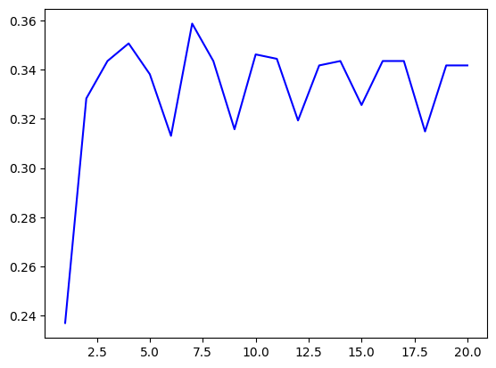
plt.title(' accurarcy')
Text(0.5, 1.0, ' accurarcy')
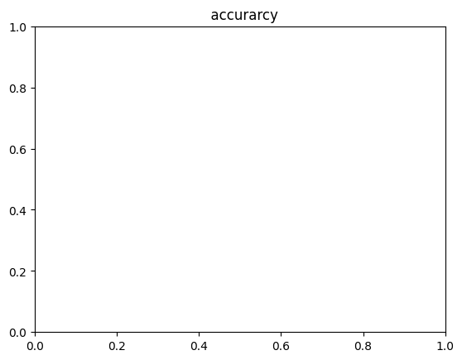
plt.legend()
No artists with labels found to put in legend. Note that artists whose label start with an underscore are ignored when legend() is called with no argument.
<matplotlib.legend.Legend at 0x19d8010d3a0>
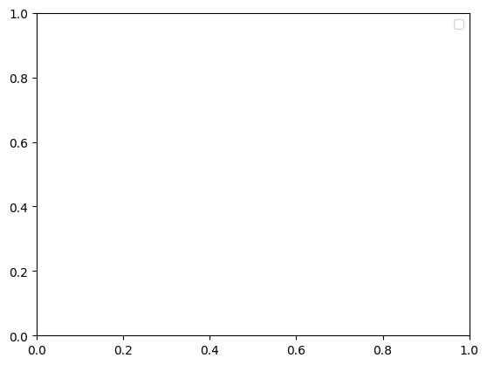
plt.figure()
<Figure size 640x480 with 0 Axes>
<Figure size 640x480 with 0 Axes>
plt.plot(epochs, loss, 'b', label=' loss')
[<matplotlib.lines.Line2D at 0x19d80177d90>]
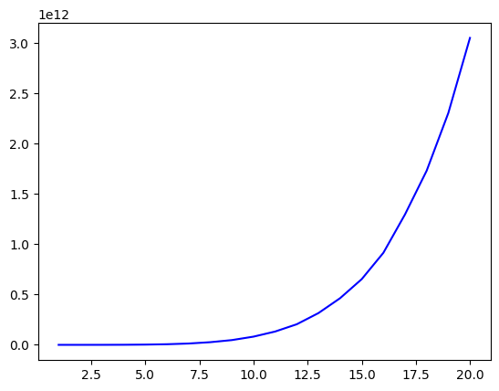
plt.title(' loss')
Text(0.5, 1.0, ' loss')
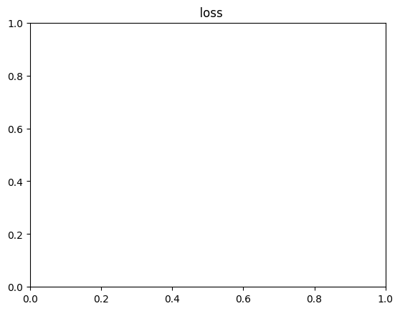
plt.legend()
No artists with labels found to put in legend. Note that artists whose label start with an underscore are ignored when legend() is called with no argument.
<matplotlib.legend.Legend at 0x19d823f1970>
plt.show()

